BILINE DEV - QA REPORT PHASE 2

FUNGSI PANDUAN, FUNGSI PROMO, & FUNGSI LAYANAN  
TWITBANK BNI 2015

horizontal line

1st: 16 OCTOBER 2015 / 1:30 - 4:30 PM

2nd: 19 OCTOBER 2015 / 6:30 - 7:00 AM

# TESTER(S)

Ali Fahmi PN (Developer)

# AGENDAS

## 1st

1. Mention + keywords cth: @bni46 #travel
2. DM #menu utk mengetahui overview layanan TwitBanking
3. DM #daftar #nama_lengkap #phoneNo untuk mendaftarkan user
4. DM promo + keywords cth: #promo #travel #hotel
5. DM Reply setiap user newly follows @bni46. [It’s ready, but currently inactivated upon Pak Dadang’s request]

## 2nd

1. DM #helpcs utk mengetahui overview keywords layanan CS TwitBanking
2. DM #cs #keyword(s) utk mengakses layanan CS TwitBanking sesuai #keywords topik
3. DM #helppromo utk mengetahui overview keywords promo BNI via TwitBanking
4. DM #promo #keyword(s) utk mengakses #promo sesuai #keywords topik promo BNI via TwitBanking

# 

# ACTION ITEMS

1. **mention** @bni46 dengan keywords: #travel

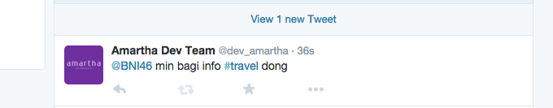

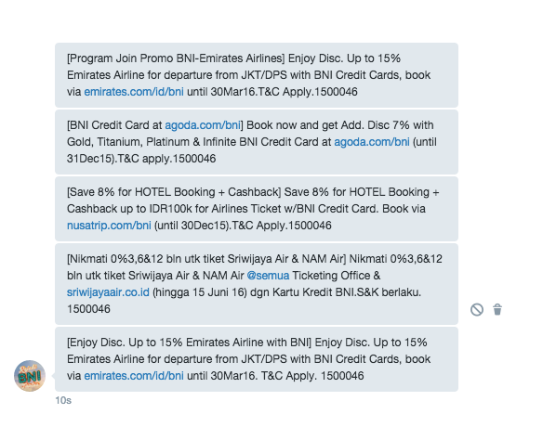

1. **DM** #menu utk mengetahui overview layanan TwitBanking

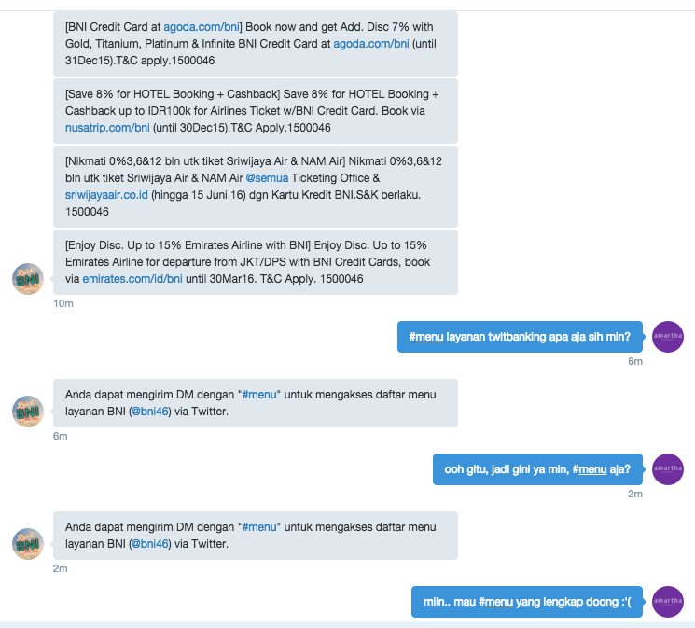

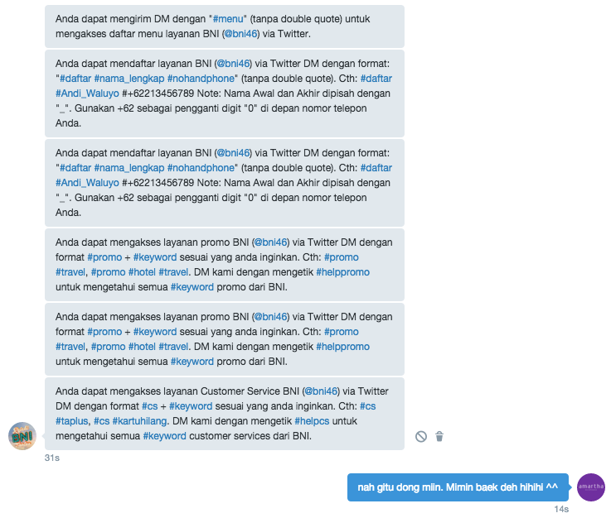

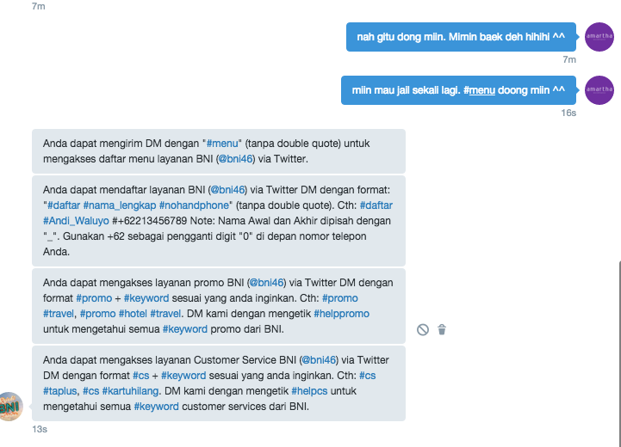

1. **DM** #daftar #nama_lengkap #phoneNo untuk mendaftarkan user

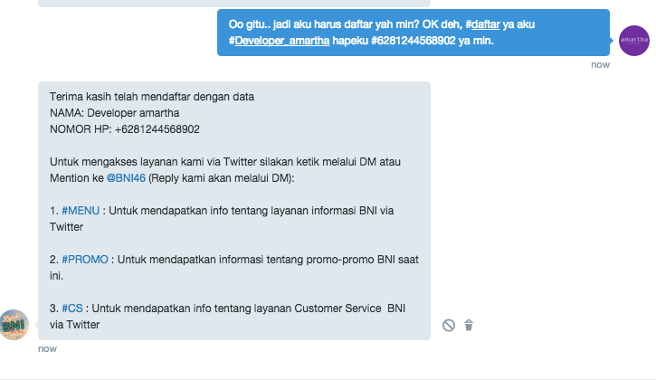

1. **DM** promo + keywords cth: #promo #travel #hotel

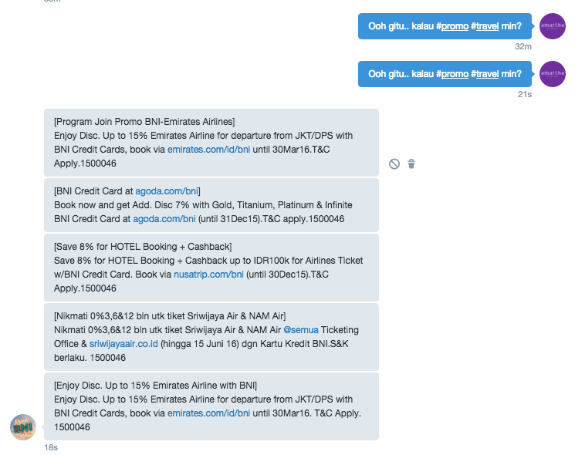

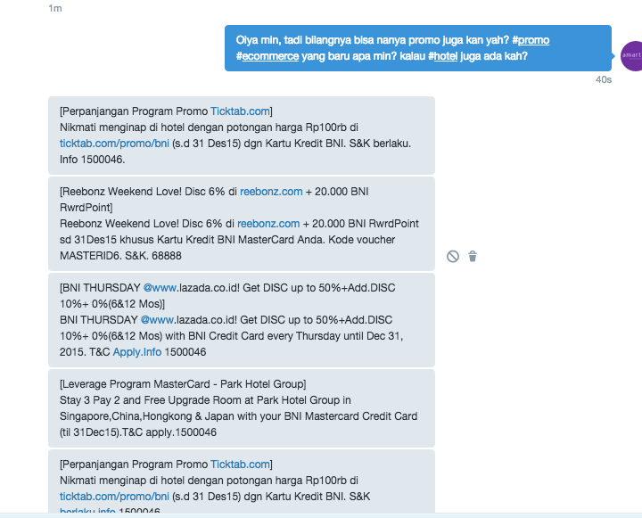

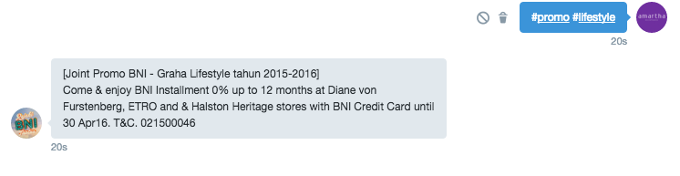

1. INACTIVATED - Auto DM to Newly Following User about BNI’s Twitter Banking
2. DM #helpcs utk mengetahui overview keywords layanan CS TwitBanking
3. DM #helppromo utk mengetahui overview keywords promo BNI via TwitBanking

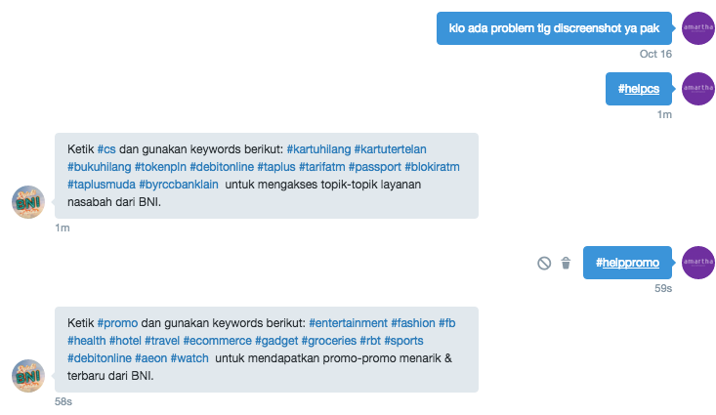

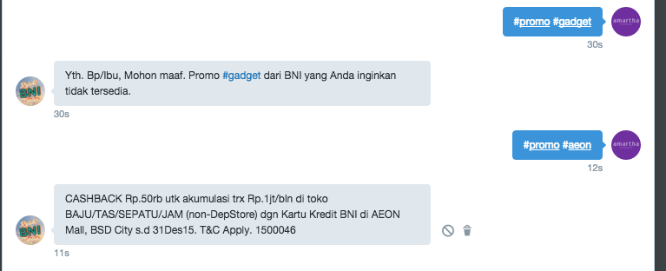

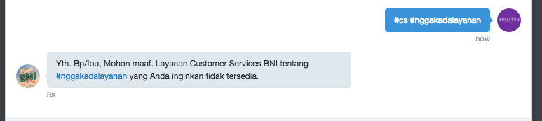

1. DM #cs #keyword(s) utk mengakses layanan CS TwitBanking sesuai #keywords topik

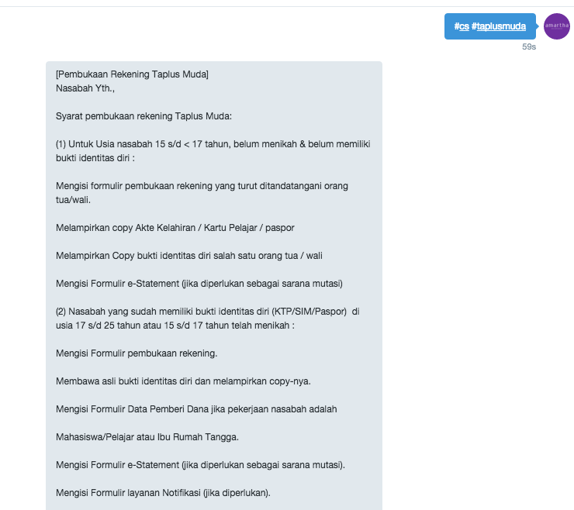

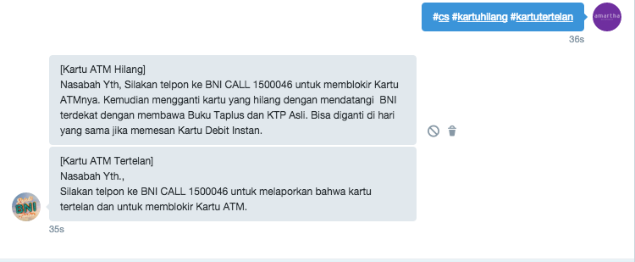

1. DM #promo #keyword(s) utk mengakses #promo sesuai #keywords topik promo BNI via TwitBanking



# NEXT WEEK’S AGENDA

N/A - All modules are completed.